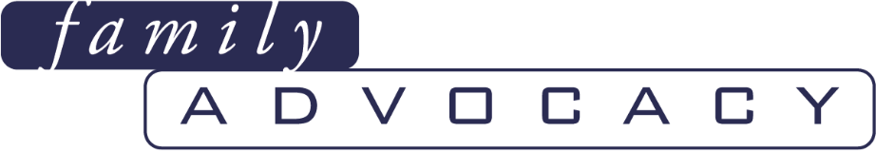

**Submission to the Audit Office of NSW on Supporting Students with Disability – Education 2023-24**

**May 2024**

***"Education is the starting point for an inclusive society".***

***Key point made by all six Commissioners of the Royal Commission into Violence, Abuse, Neglect and Exploitation of People with Disability***

Cecile Sullivan Elder, Executive Officer, [cecile@family-advocacy.com](mailto:cecile@family-advocacy.com)

Leanne Varga, Systemic Advocate and Campaigns Manager [leanne@family-advocacy.com](mailto:leanne@family-advocacy.com)

Family Advocacy (02) 9869 0866

Suite 704, 88-90 George Street, Hornsby, NSW 2077, Australia

**Acknowledgement:**

Family Advocacy would like to acknowledge the traditional custodians of the lands on which this report has been written, reviewed and produced, whose cultures and customs have nurtured and continue to nurture this land since the Dreamtime. We pay our respects to their Elders past, present and future. This is, was and always will be Aboriginal land.

# Table of contents

Table of contents 2

Introduction 3

Overview 4

(a) Strengthen Support: investing in teachers and other support staff 5

(b) Increase resources and flexibility: enabling schools to operate with more flexibility 7

(c) Improve the family experience: making experiences better and easier 10

(d) Track outcomes: building an evidence base to measure progress 16

Conclusion 17

# Introduction

Family Advocacy is a not for profit disability advocacy organisation that works across New South Wales (NSW) to advance and protect the rights and interests of people with developmental disability to live a meaningful inclusive life and have access to the same opportunities as the majority of Australians. This means being included in education, employment, and community with the right to live safely, with dignity, and free from violence, abuse, neglect or exploitation.

We were founded 32 years ago by families whom work with, for, and on behalf of, people with disability. We continue to be governed by families and provide support in the following ways:

* Advocacy advice and advocacy information to individuals
* Advocacy development for family members of a person with disability
* Systemic Advocacy

Family Advocacy appreciates the opportunity to provide a submission to the Audit Office of NSW. We note this audit will assess whether the Department of Education’s Disability Strategy is effectively supporting students with disability in NSW public schools across four key reform areas:

* *Strengthen support*: investing in teachers and other support staff
* *Increase resources and flexibility*: enabling schools to operate with more flexibility
* *Improve the family experience*: making experiences better and easier
* *Track outcomes*: building an evidence base to measure progress.

We note Family Advocacy was consulted during the audit scoping phase on 23 August 2023. Given that it was nine months ago, this submission provides a more recent update along with additional material designed to bolster our communications from that consultation.

Our comments and recommendations are premised on more than three decades of working with families who experience inequities and failures in the education system in New South Wales. Family Advocacy has been a part of the many reviews, roundtables, working groups and inquiries about students with disability over decades. This includes the 2017 Upper House Education Inquiry which ultimately led the formulation of the NSW Department of Education Disability Strategy and Inclusive Education Policy. We stood alongside people with disability and their families throughout the Disability Royal Commission over the last five years and the NDIS Review over the last year, supporting them to share their experiences. We were part of an expert panel at [Disability Royal Commission Public hearing No. 7: "Barriers to](https://www.family-advocacy.com/latest-news/drc-hearing-evidence2020/) [accessing a safe, quality and inclusive school education and life course impacts".](https://www.family-advocacy.com/latest-news/drc-hearing-evidence2020/) and more recently, the current [Upper House Inquiry hearing on Children and young people with disability in NSW educational settings](https://www.parliament.nsw.gov.au/lcdocs/transcripts/3251/Transcript%20-%20PC3%20-%20Children%20and%20young%20people%20with%20disability%20in%20New%20South%20Wales%20educational%20settings%20-%2022%20April%202024%20-%20UNCORRECTED.pdf). In addition, Family Advocacy is on the steering committee of the [Australian Coalition on Inclusive Education.](https://acie.org.au/acie-roadmap/)

We appreciate the NSW Department of Education’s intention to make the education system more inclusive, however, we share a number of concerns/criticisms as well as suggested solutions below.

Due to the breadth and depth of our experience in the education area at the individual advocacy and systems levels, we believe we are in a good position to provide valuable feedback to the Audit Office of NSW and accordingly, would welcome the opportunity to provide any further feedback if desired.

# Overview

**General Commentary on the NSW Disability Strategy**

Since the beginning of the 21st century, there have been many government reviews and inquiries regarding NSW students with disability in the education setting which we have been involved with, at least five in NSW and eight at the National level, highlighting the inequities and system failures have been noted over and over again. We know what needs to be done. Despite so many recommendations for reform, our education enquiries have continued to rise steadily over the last 5 years.

Whilst there have been some positive initiatives coming out of the NSW Disability Strategy, the issues that are being raised by families suggest that the situation has not substantially improved with our education related inquiries over this same period have risen steadily by 25 per cent. These calls mostly relate to the same systemic issues around gatekeeping, a lack of reasonable adjustments which often lead to suspensions, segregation and low expectations with poor outcomes projected for many of these young adults as a consequence.

From the 2017 Upper House Education Inquiry, because of “Recommendation 10 - That the NSW Department of Education increase support classes in mainstream schools to adequately meet student need.”, mainstream classrooms have not had the impetus to become more inclusive when schools know the new support units will continue to house students with disability, effectively kicking the can down the road and allowing the status quo to continue.

Another observation we can provide are the NSW government supported for pre-service scholarships for special and inclusive education. We have been advised that one of the conditions are that upon completion the teacher has no choice but to work in a special school for five years otherwise they have to return the scholarship funds. This goes against the intentions of the intended reform to improve inclusion in the mainstream and talks to a major issue of misalignment with the objectives of the Disability Strategy and initiatives to remediate this. We are aware that change across any system is difficult, however, when there is a misalignment with the intention and the actions taken, any approaches at successful change are significantly reduced.

Further as part of the 2017 Inquiry, the NSW Ombudsman tabled a Special Report to Parliament, Inquiry into behaviour management in schools[1]. The inquiry was a major piece of work and was initiated as behaviour management in schools had featured in a significant number of complaints and other matters (including employment related reportable conduct) brought to the Ombudsman’s Office. That our advocacy enquiries have remained steady and continued to rise with the same issues suggests that the “Proposals for reform” in this report have not been implemented adequately, if at all.

We continue to be alarmed by NSW Department of Education not utilizing an evidence-based description of what constitutes inclusive education, adopting strategies to remediate barriers that do not consider the internal barriers that work against this. Nor is this assisted by the revolving door of government staff attempting to grapple from a novice perspective on what change is required. From this perspective, the lack of positive reform is not surprising and comes with a high level of caution that this will again repeat itself if not approached differently.

## (a) Strengthen Support: investing in teachers and other support staff

|  |
| --- |
| *“Overwhelmingly, families report that the skills and attitudes of the school/teacher as to whether their child receives the appropriate adjustments and supports is key, and families are even saying that minor adjustments that could make a significant difference in many cases aren't occurring.”*  *- Cecile Sullivan Elder, Executive Officer, Family Advocacy giving evidence at the* [*Disability Royal Commission Public hearing No. 7*](https://www.family-advocacy.com/latest-news/drc-hearing-evidence2020/) |

We do not pretend to be educators however, the advocacy enquiries we receive from families backs up the extensive research which shows teachers have a fundamental role to play in school inclusion with their attitudes, responsibilities, performance and support needs. There are three broad determinants of the teaching role that underpin greater inclusion/participation of children with disability in mainstream settings: **teaching competence** (knowledge, skills and attitudes), **commitment to opportunity creation**, and **collaborative ways of working** (such as co- teaching and peer learning)[2].

Teachers are responsible for classroom relationships and have a significant influence upon how students are viewed by their peers. Teachers must run their classrooms and teach the curriculum in a way that all class members can participate without being singled out. This requires consideration of different learners’ needs from the outset, which is a principle of Universal Design for Learning. We have no doubt the Department of Education can provide you with a list of course offerings they provide to show their investment in teachers and other support staff. However, what we observe in our dealings with the Department of Education is they may offer training on fundamental topics such as The Universal Design for Learning but it is not made mandatory, it is not well promoted, it is difficult to find it on their website and does not provide good practical follow up.

Training is often not co-designed with people that have lived experience that may be able to share valuable input. For example, the Department is well aware of the disproportionate number of students with disability that are being suspended which we continue to hear about on a weekly basis through our calls from parents and the majority of the time the student is neurodivergent. The neurodivergent student/parent may be able to insights on how reasonable adjustments could be made to fill in this gap so the student can have access on the physical, social and curricula level.

We would encourage that all school personnel receive training in disability competency in a similar way as cultural competency education, which could include topics such as forming right relationships (knowing the child), understanding behaviour as a form of communication, trauma informed practices, restrictive practices and the harm they do, ableism and unconscious bias. If a student feels safe, understood and valued, then they can learn. Where there are times when a student becomes unregulated, there is now much research to empower a teacher on how to support the student to de-escalate a situation by getting to know the child, being understanding and making reasonable adjustments.

**Ensure effective use of teaching assistants.** The physical presence of teacher assistants can be positive and negative. They can act as interpreters or mediators, discouraging harassment or belittling, but can also limit opportunities for peers to speak to each other freely[3]. There is the concern that the student with the greatest need end up receiving instruction from a teaching assistant (who is the less educated on how to teach), and spending less time with their teacher. Whilst there are benefits, there are dangers if teaching assistants are not used intelligently. We heard of one family where the student had so little interaction with the teacher they did not even know their teachers name. The United Kingdom invested heavily in early 2000s but this did not boost learning[4] as it cut the amount of time these students spent with their teacher. These risks can be avoided with better planning and training. We draw the NSW Audit Office’s attention to the Evidence for Learning’s Guide (2019) [Making best use of Teaching Assistants,](https://evidenceforlearning.org.au/education-evidence/guidance-reports/teaching-assistants) Sydney: Evidence for Learning’ and suggest the recommendations be adopted by the Department of Education as a way of being more effective and efficient.

**Employment representation matters**. We would also argue investing in teachers and other support staff includes increasing disability employment representation. Of particular significance is the poor employment record of the Department of Education of people with disability. Out of nearly 100,000 employees[5], there are only 1,817 employees with disability[6] (1.2%), well below the NSW governments commitment to increase representation of people with disability in the NSW public sector to 5.6%[7] and extremely low compared to the fact that people with disability make up 17% of the NSW population[8]. There is much scope for improvement and we encourage the Audit Office to make recommendations in this vein.

Whilst we are not educators, we do make it a priority to be connected with relevant academics around the country and keep abreast of the latest research both in Australia and abroad. We encourage the Audit Office of NSW to seek further information from:

[Inclusive Educators Australia](https://inclusiveeducators.org.au/) (IEA) - an organisation established to represent and support inclusive education professionals who are committed to advancing quality inclusive education practices in Australian schools. IEA recognises the professional knowledge and skills of inclusive educators and promotes and supports their valuable leadership across schools and education systems. IEA is focused on celebrating and advancing inclusive education reform efforts, and is committed to building the confidence and capability of the education workforce to ensure scalable and sustainable change across classrooms, schools, and education systems.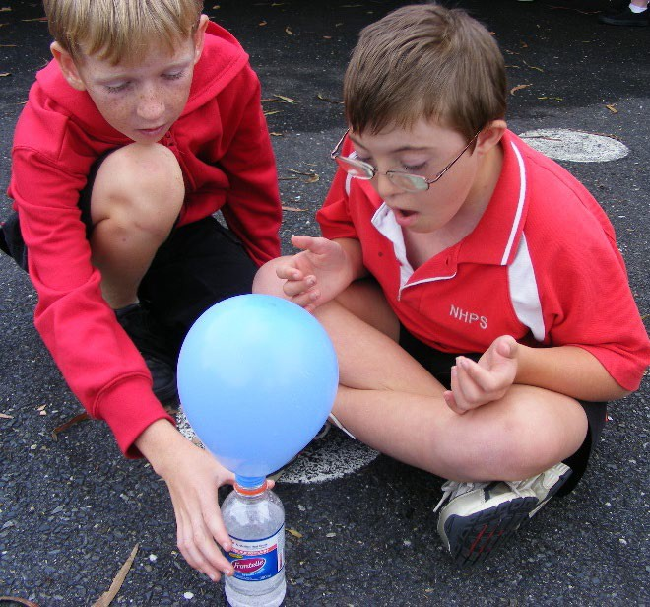 [Centre for Inclusive Education, QUT](https://research.qut.edu.au/c4ie/) - which aims to produce high-quality impactful research on matters that affect students in school education with the purpose of reducing exclusion and increasing inclusion to provide all children and young people with equitable opportunities to learn and develop as independent and valued human beings.

We highlight their recent book launch and highly recommend the NSW Audit Office reads Graham, L.J. (2024) *Inclusive Education for the 21st Century: Theory, Policy and Practice*, Second Edition, NY Routledge. Video recordings of the book launch and purchase of the book can be accessed [here.](https://research.qut.edu.au/c4ie/events/inclusive-education-for-the-21st-century-second-edition-book-launch/) This book takes a comprehensive look at the question: How can teachers and schools create genuinely inclusive classrooms that meet the needs of every student? It explores evidence-based strategies to support diverse learners, learning from international experience, multi-tiered systems of support, implementing systemic inclusive education reform from the policy level right through to classroom practice. With many schools still operating with 20th Century models that disadvantage students, this book presents the deep knowledge, tools and strategies to better equip pre- and in-service teachers and leaders to make inclusive education a reality in all schools.

Where we have seen positive examples of school transforming to be more inclusive, this is also often led by the school leader, the principal. Leadership in this regard can have a remarkable impact on the individual teachers and others roles and processes within the school community. For this reason, we encourage the Audit Office to recommend a greater investment in school leaders understanding good inclusive practices.

We note, our suggestions are reinforced by Disability Royal Commission Recommendation 7.3 - Improve policies and procedures on the provision of reasonable adjustments to students with disability and Recommendation 7.8 Workforce capabilities, expertise and development.

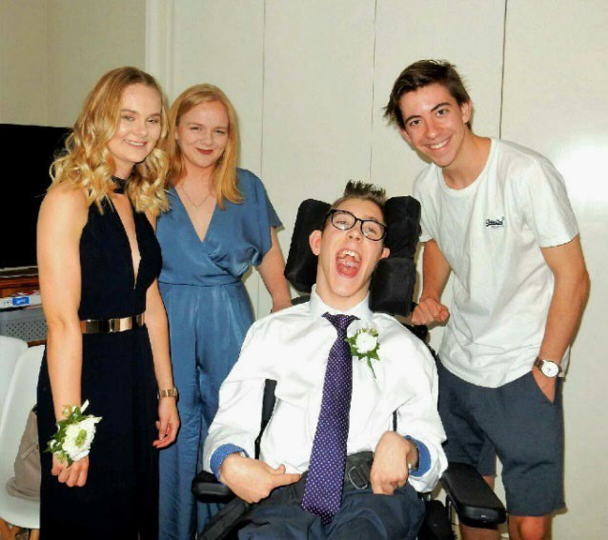**Film showing the benefits for all if provided with adequate supports**

We encourage the NSW Audit Office to recommend this video be watched broadly throughout NSW schools to help shift mindsets.

**Inclusive High School Education** - [Al’s story](https://www.youtube.com/watch?v=lkbsmv22wCg&t=17s) - (15.51 minutes) This film is about Al Graham and his inclusive education journey through the lens of his last week at Turramurra High School in NSW. Thank you to the Graham family and Turramurra High School.

Al’s school mate - “The opportunity it’s given me and others has been really significant to our lives and had a really huge impact on us”.

Al’s teacher - “All those soft skills go out into the workforce and out into the community, and that’s where you start to get the inclusiveness that you want in our communities, and the acceptance, the promotion of diversity”.

## (b) Increase resources and flexibility: enabling schools to operate with more flexibility

It is essential NSW has full School Resource Standard funding for government schools with adequate disability loadings and a time responsive system to fund improvements to support the needs of children and young people with disability. Some parents have also commented on the need for transparent reporting on how the Integration Funding Support is applied for each child.

Whilst we appreciate resourcing is important to support the needs of children and young people with disability, funding is an issue but not a standalone one. We caution the NSW Audit Office to believe that funding is the silver bullet solution to all of the issues faced and to factor in the influence of the school’s culture and attitude of the school community to be inclusive. Lack of funding can be used as a scapegoat when a principal does not have the ‘willingness’ for the student with disability to come to their school. But many times, we hear from families, funding barriers can be overcome when there is a “willingness” of the Principal or positive attitude of the teacher to include. One very simple example is where a young non-verbal student was included in the school play by dressing up as the wind. Or where one student with disability was taught how to skip with a rope by his friends in the playground which was a skill the student’s Occupational Therapist had been trying to teach him in therapy for 1 year without success.

There are many other examples such as these where the student has learned socially and academically from their peers. The United Nations has called upon Governments that are signatory to the Convention on the Rights of Persons with Disabilities (CRPD) to adopt practical but progressive systems to transfer resources from segregated settings/ special schools into mainstream schools. For many years now, we have recognised that a dual system ties up much needed resources and keeps the expertise of our special educators from where they are needed the most: facilitating the meaningful and valued participation of students with disability alongside their brothers and sisters and neighbourhood friends. The Disability Royal Commission has also proposed that inclusive education can only be achieved through ongoing enhancement of mainstream practices alongside a phased and responsible transition away from segregated approaches.

We bring to the NSW Audit Office’s attention the inclusive education system in New Brunswick and [Policy 322](https://inclusiveeducationcanada.wordpress.com/wp-content/uploads/2013/11/6-322a-new-brunswick-2013-inclusive-education-policy.pdf) issued in 2013 and was recognised as a global exemplar at the 2016 Project Zero Conference. Policy 322 adopts the definition of inclusive education as per General Comment No. 4. and states the goal of Inclusive public education:

* Recognises that every child can learn.
* Is universal – the provincial curriculum is provided equitably to all children and this is done in an inclusive, common learning environment shared among age-appropriate peers in their neighbourhood school.
* Is individualised – the educational program achieves success by focusing on the child’s strengths and needs, and is based on the individual’s best interest.
* Is requiring school personnel to be flexible and responsive to change.
* Is respectful of children and staff diversity in regards to their race, colour, religion, national origin, ancestry, place of origin, age, disability, marital status, real or perceived sexual orientation and/or gender identity, sex, social condition or political belief or activity.
* Is delivered in an accessible physical environment where all children and school personnel feel welcome, safe and valued.

We invite the Audit Office to recommend the adoption a similar policy to Policy 322 which has the same definition of inclusion as General Comment No. 4 as well as these principles, and no segregated education.

In our opinion, the current NSW Disability Strategy will keep NSW is an endless cycle of review, predictable findings and ineffective responses, and leaves students with disability in a suboptimal environment whether it is mainstream or special schools. A segregated education system tends to lead to a segregated life. When it comes to avoiding harm and making a positive difference in the lives of children with disability and their future adult selves, we believe we must set our sights on the creation of inclusive schools.

Mainstream schools as they currently exist struggle to consistently provide what parents want and importantly, what the student needs. But special schools do not and can *never* offer an acceptable alternative, not even if co-located with mainstream schools or with programs to occasionally share experiences with non-disabled peers. These are flawed, simplistic suggestions for fixing complex problems and have had little success in the past. To keep the status quo and continue with a dual system (presumably to keep all parents happy) dilutes our efforts for *real change* and distracts from the critical work of making an authentic difference in the lives of students with disability. We strongly encourage the Audit Office be brave and informed in this regard. This point in time with major disability reforms expectant, marks an opportunity for NSW to be leading the charge amongst the other States and Territories.

Whilst special schools or classrooms exist, students will fill them. Whilst support units arise, students will fill them. History shows us that the existence of special schools and support units clouds our educational vision for students with disability and keeps inclusive education reform locked in an ever-circling holding pattern. Certainly, there must be a transition time for the decommissioning of special schools, but without a firm end date in mind for the era of segregation, our legal obligations towards students with disability will always be a distant dream, unattainable and out of reach. 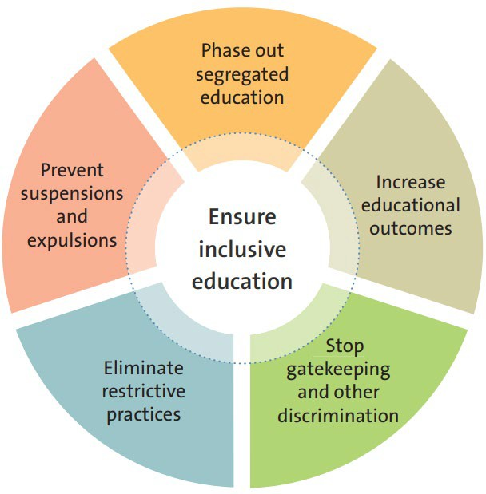

As mentioned in the introduction, this is not the only time education for students with disability has come under government review/inquiry at State and Federal level. We know what needs to be done – to transform our education system. No more tinkering. The responsibility to address this lies with government to do the right thing so students with disability don’t fall through the cracks but rather have the same opportunity to reach their potential, to learn, to get a job, have friends, and live a good life. In this regard, we draw the NSW Audit Office’s attention to recommend the adoption of Australian Coalition’s for Inclusive Education’s [‘Driving change: A roadmap for achieving inclusive](https://acie.org.au/acie-roadmap/) [education in Australia’,](https://acie.org.au/acie-roadmap/) outlining a 10-year Roadmap. It is underpinned by six key pillars to help realise inclusive education in Australia and prevent the violence, abuse, neglect and exploitation of students with disability (diagram shown). We acknowledge this was written at the start of the Disability Royal Commission and requires some refreshment and updating and needs to be tweaked to be NSW centric; but the Roadmap is an excellent starting point.

|  |  |
| --- | --- |
| *Receiving recent Budget Estimates revealed:*  *Total funding for all NSW public Schools for Specific Purposes for the last five years is:*   * *2019 - $302.6 million* * *2020 - $363.2 million* * *2021 - $375.7 million* * *2022 - $398.3 million* * *2023 - $414.0 million* | *Total funding specific to support classes in NSW government schools (mainstream or Schools for Specific Purposes) for the last five years is:*   * *2019 - $498.3 million* * *2020 - $560.0 million* * *2021 - $619.1 million* * *2022 - $680.6 million* * *2023 - $740.4 million* |

Whilst we do not claim to be economic experts, we can observe the figures revealed in Budget Estimates which show that rather than moving toward inclusive education and away from segregated education, $1.154 billion was spent on segregated education in 2023, an increase of $75.5 million from 2022 ($1.079 billion). This is comprised of $414 million for SSPs, an increase of $15.7 million from 2022 ($398.3 million); and $740.4 million on support classes in mainstream or SSPs, an increase of $59.8 million from 2022 ($680.6 million).

The desegregation of support units and schools for specific purposes can be supported by reallocating the $1.154 billion and any additional funding that was due to be allocated in 2024 to SSPs, to measures that will progressively realise inclusive education.

## (c) Improve the family experience: making experiences better and easier

|  |
| --- |
| *School education settings - Students don’t feel supported to learn and engage in activities at school.*   * *Only half (54%) reported feeling welcome and included* * *70% of students reported being excluded from events or activities at school* * *65% of students reported experiencing bullying and 13% preferred not to answer* * *Only 27% reported feeling supported to learn at school* * *Only 35% of families felt teachers and support staff have adequate training and knowledge to support the student*   *Children and Young People Australia Education Survey 2022 - for families and caregivers of children and young people in school. Note: 28% of families that answered the survey were from NSW* |

Parents must be respected for their expertise in knowing their child the best, and as such be fully involved and listened to when it comes to the education of their child or young person with disability.

Many families that have had a bad experience and then a good one, have credited the attitude of the principal and the competency of the teacher plus parent collaboration that are the key ingredients to success. Family Advocacy was funded by the Department of Education to create [Conversations for Collaboration,](https://conversationsforcollaboration.com/) a practical toolkit for parent/teacher collaboration. To save the Department of Education money by not reinventing the wheel, we recommend the adoption if this resource be implemented broadly through to every school in NSW in order to support teachers/families/students and also prevent the types of problems which we discuss below.

**Gatekeeping continues.** Many families who have children with disability continue to face gatekeeping or forced partial enrolments, and therefore their experience is not better and easier. Many families attempting to enrol their child in a regular school they are often told that their child does not belong there, that their child is better supported in another environment and that they will not be doing the best by their child and the other students if they choose this. For these families, advocating for supports and genuine inclusion is hard and as parent, the sense that their child is already not wanted there plays a heavy toll for loving parents.

Family Advocacy has asked parents to list the explanations they had been given by school leaders/ principals when seeking enrolment in their local school. We share some below:

|  |  |
| --- | --- |
| *But this is what we have always done*  *Teachers aren’t therapists*  *They are becoming mainstream but not there yet*  *We do reverse integration*  *You have your head in the clouds*  *You do realise your child has a disability*  *When they grow out of disability they can come*  *You haven’t accepted your child’s disability*  *We already have a child with disability*  *We only take children with high functioning disability*  *You don’t always get what you want in life*  *Your child is not disabled enough for individual funding*  *There is such a big academic gap so it won’t work*  *They are not a good fit*  *This will be too exhausting*  *We don’t have enough resources*  *We don’t know how to teach disabled children in mainstream*  *Our teachers aren’t babysitters*  *Our teachers aren’t nurses*  *We have no specific disability knowledge*  *Your child is a risk to others*  *We are already dipping into the general budget*  *Kids are cruel so they are better off somewhere else*  *Their self-esteem will be affected*  *We have no resources*  *We don’t have the skills*  *We can’t afford the modifications* | *Your child won’t get funding*  *Our school is heritage listed so it’s not a good idea*  *When she is toilet trained*  *My teachers don’t have to teach your child*  *You got lucky in primary school*  *The gap gets wider so why put them through it?*  *They will take teacher’s attention away from the children*  *Will you be paying for this?*  *You don’t realise how tired this will make the teachers*  *We are not experts*  *They won’t identify with their peers*  *You will get backlash from other parents*  *We don’t teach them*  *She can’t be educated*  *He doesn’t meet school requirements*  *She can’t come here because we can’t lift her*  *We have done all we can*  *We can’t solve all the world’s problems*  *Your child is not a good fit*  *There are special places for your child*  *You are ruining your child’s future*  *You are not doing the best for your child*  *Your child doesn’t belong with adolescents*  *We will get a teacher’s assistant to teach them*  *There is best practise and there is reality*  *It will be an unjustifiable hardship* |

**Lack of reasonable adjustments continue.** This leads to academic and social disadvantage, unnecessary suspensions/expulsions.

Children and young people with disability should not be disciplined because of their disability. To their credit, the Department of Education’s submission with the Disability Royal Commission made the admission “the suspension rates for vulnerable students in NSW are too high and disproportionately so for students with disability”, strongly pointing to systems failure. Our advocacy enquiries from families in relation to multiple suspensions due to lack of reasonable adjustments have continued to rise year after year. The official position of the NSW Department of Education Student Behaviour policy says suspensions are not designed to be punitive, but rather to give the school, student and parents time to put strategies in place to help avoid a similar situation in the future. However, the parents we hear from do not see any changes occurring in the process, the environment or the way their child is understood or considered and yet they are expecting a different result from the child. This is unreasonable, ineffective and is on constant repeat. There is also no research evidence that the general use of suspensions reduces the disruptive classroom behaviour and the research shows that suspension may exacerbate challenging behaviour for students with disability or trauma (Graham., L).[9]

It is common for our advocates to hear from families what we heard throughout the Disability Royal Commission: how the education system is failing to support the basic needs of each student. We heard how despite good intentions of policy, the unwelcoming nature of schools has meant many children and young people continue to “lose out” on the opportunity of gaining a quality education. The impacts on the student and their family can be very damaging. There are many negative consequences such as lack of academic progress due to extended suspensions, expulsion or home schooling often borne out of inequities in the system which comes with poor self-esteem and social stigma. A heavy onus is placed on the parent to have to advocate for their child on a regular basis which is all encompassing and time consuming. Often this advocacy is around predictable and avoidable scenarios such as support considerations that have been made clear through informal and formal processes. It is not uncommon for parents to forgo employment opportunities, to end up on reduced hours or to lose their job altogether due to having to take too much time off work.

*I am a single parent and lost my job after my child (in primary school) had three suspensions for extended periods of time. This caused a significant loss of income for me with the flow on affect proving quite detrimental for the whole family unit. Frustratingly, I offered many of the strategies that I knew would supports my child which were not undertaken consistently, and then forgotten. Meetings to resolve this so my child could return to school were not followed through with. This could all have been avoided with good communication, collaboration and a willingness to fail forward, meaning giving things a go and learning from them if they don’t work. Like every child, my child deserved the opportunity to reach their full potential, to be able to learn and play with his neighbourhood peers.*

*Sadly, he was denied this opportunity.*

- *Parent*

This is one of many stories that highlight the ineffective processes and attitudes within NSW schools with the ripple effect being very significant for many families. This takes a heavy toll on families, financially and emotionally.

**Life Skills is problematic and needs to be scrapped.** Education attainment for our students with developmental disability are typically via a Record of School Attendance (RoSA) and not a Higher School Certificate (HSC). Many do not complete through to Year 12 as schools find it increasingly hard to accommodate and are thwarted by systems that require registration to HSC or Life Skills pathway which means many electives are not available to students not doing full stage outcomes or Australian Tertiary Admissions Rank (ATAR). Family Advocacy has observed a strong funnelling from schools into the Life Skills program which is segregation via curriculum and is not a pathway to work as it is so limiting. Many families, however, are supported by Family Advocacy to advocate around this and at times with success in gaining access to electives for their children. This constant advocating although comes at a great cost to many. Importantly, electives provide some experimental insights for young adults into possible future work roles. Over the many years the Life Skills program has been utilised as an educational tool for students with disability, there is no evidence that it sets students up for a future for work and adulthood. This component of the education system is very problematic and it resembles the institutional medical model-based practices from many years ago. We strongly recommend that this practice including its outcomes be reviewed.

**The Student Behaviour Strategy is weak as a tool to reduce suspensions**

|  |
| --- |
| *“My child with disability was regularly suspended in the mainstream, was “kicked out” to the support unit, then “kicked out” to the special school then “kicked out” of the special school. The enrolment hours were reduced to part-time without any recourse for appeal or any attempt to get to know my child, understand their disability, make reasonable adjustments or communicate effectively. I found out he was locked in a room by himself and this was extremely traumatic. He has been suspended for more than the allowable days and clearly very little education.*  *I am on the verge of a breakdown. I complained to the Minister and it bounced back down the line to the Department District office. There is no sense of due process or proper remedy or genuine care for my child’s well-being or education.”*  - *Parent* |

Budget Estimates reveal in 2022, 15,385 students with disability were suspended. This comprised of 11,800 in mainstream schools, 2893 in support units, 692 in schools for specific purposes (special schools).

These statistics challenge the common myth that “special school” and “support unit” means better for students with disability. Parents are convinced by Principals and teachers that being choosing these segregated settings, their child will be safer and learn better with lower staff: student ratios. One would expect the rate of suspensions to be low to negligible. Instead, the number of students with disability suspended as a proportion in these segregated settings is higher than in the mainstream system. This suggests special schools and classrooms are not as great as is being presented to parents. This also suggests strongly that our schools are not providing what’s required to support its students.

A six-year longitudinal study investigating the development of severely disruptive behaviour funded by the Australian Research Council[10], observed these children and watched what they were getting in trouble for. It wasn’t “violence”, although it would often end up described that way. Much of what was construed as violence was, especially in prep, the inadvertent result of poor spatial awareness, poor self-regulation, and lower oral language competence. The study explains eleven reasons why exclusionary discipline does not work and we encourage be read by the Audit Office.

We recommend the Student Behaviour Policy needs to include a mechanism which triggers an investigation where a student is suspended more than three times in order to ensure the student is afforded any reasonable adjustments which they may not be receiving and to give the school an opportunity to build their inclusive capacity. We also recommend that there must be an independent complaints mechanism to capture policies and practices that fail many students in this process.

A common scenario is where the child with disability gets into trouble as they adjust to their new environment on Day

1. On Day 2 the child is getting into trouble for not sitting on the floor. This is for children with a known diagnosis for which concentration and attention are challenges. These types of issues whereby the child is a square peg being asked to fit into a round hole. By week 4, the child is threatened with suspensions and by week 5, the child is suspended. Our advocates who have been working for Family Advocacy for many years are so frustrated as they continue to hear the same types of discriminatory happenings all over NSW year after year without any systemic reforms being adopted by the Department of Education. This highlights the need for an independent complaints process discussed below.

The impact on the student, the cost to families both financial and social, cannot be underestimated. The consequences of these suspensions do not stop with the event, as often a child is then ‘labelled’ as bad, troublesome, violent, and this may carry through with the child for their entire schooling, often setting up expectations with educators and others to expect the worst from this child. There are reports of many families resorting to home schooling after multiple suspensions in primary school or school refusal where the student simply cannot go to school as they do not feel safe. This has a flow on effect on a family’s income capacity, as well as an impact on a child’s academic and social learnings.

**Extra challenges faced in regional, rural and remote areas**. Family Advocacy collaborated with Disability Advocacy in the report ‘Falling Behind: A Need For Inclusive Education’, which was based on consultations and interviews with people with disability, their parents, teachers and principals in rural, regional and remote areas.

Students with disability in regional, rural and remote areas face similar significant challenges in education settings as we have discussed, but are double disadvantaged, with geographical issues such as thin markets with less options for schooling, social isolation, and inaccessible built environments. Schools can also face challenges attracting and retaining skilled teaching staff.

Not having an independent complaints system in these locations can be particularly problematic as, living in close- knit communities where anonymity is difficult, families may be reluctant to escalate matters for fear of retribution and/or back door communications between local schools which can lead to gatekeeping. This scenario is no different for families in metropolitan areas except that a family in a rural, remote or regional area may have to relocate to a regional/metropolitan area to find another school. Unfortunately, we have seen this occur many times.

For this very reason, it becomes even more imperative to get inclusive education right in regional, rural and remote areas so children with disability can attend their local school and families do not have to travel long distances to out of area special schools or worse, have to relocate their entire family.

**Need an independent complaints system.** The Disability Royal Commission’s Recommendation 7.10 Complaints management suggests “State and territory governments should create or expand existing complaint management offices that operate within educational authorities at arm’s length from schools to help resolve complaints about schools, specifically complaints concerning the treatment of students with disability”. Family Advocacy has long been advocating this as well ensuring apart from being independent, it is also effective, accessible, transparent, safe and enforceable with legal remedies attached (as required to comply with international conventions, including the CRPD).

Many of the enquiries we hear are from families expressing the very real power imbalance that exists between the whole school system and the student/parent dynamic. Schools can exercise unfettered discretion. Even though

the [**Disability Standards for Education 2005**](https://www.legislation.gov.au/Details/F2005L00767) and the [**Disability Discrimination Act 1992**](https://www.legislation.gov.au/Details/C2018C00125) have existed for a long time, there are still no effective polices in place to make sure students with disability have equitable access to a quality education. Schools continue to investigate themselves which leads to a potential conflict of interest. Parents are not given a voice in these processes.

*The Disability Standards for Education are not taken seriously, schools are aware of their obligations but choose to break them by constant gatekeeping on enrolment and curriculum, and bully parents who hold them accountable to these standards. To me it is just paperwork with no power in it because the Standards are being ignored and schools continue to diminish their responsibility to the student and not take the Standards as seriously as they should. Need greater compliance and enforcement.*

*Parent*

In cases where a parent does complain, our 2020 survey revealed 70% of parents were not satisfied with the current complaints process (27% very dissatisfied and 43% dissatisfied), with only 17% stating they were satisfied. Parents expressed the current complaints mechanism lacks objectivity, accountability, transparency and timeliness. The Principal backs the teacher, the regional office backs the principal, and so it goes up the bureaucratic line within the Department. A big problem lies in the complaints process not being independent. We hear in many instances where students are subject to repeat suspensions which, in the absence of an appeals process, are subject to limited oversight, monitoring and review beyond the school.

|  |
| --- |
| *I hope change can happen if the Department are truly serious and actually want to change the way things are done. Firstly, it must start with not having the Department investigate itself when parents make complaints. This is simply not acceptable as you will never get fair or just outcomes to complaints made. There also must be 100% transparency throughout the complaints process, accountability and support for students and their families throughout the complaint process who have suffered trauma and abuse at School.*  *Parent who felt she had no choice but to home school as the school system failed her children* |

|  |
| --- |
| *There is no independence to complaint systems. Parents of students with disability and students with disability are very vulnerable to the consequences of lodging complaints. Therefore, they tolerate harassment and victimisation that many others would not. The system is geared to the education staffer being presumed in the right, especially as the process is initially undertaken by the school itself. It could be vastly improved by an independent complaints process.*  *Parent* |

One of our families shared that after making a complaint about the school, she was refused access onto the school grounds. Unlike the consequence of a suspension against the student, the parent had no recourse or power in this scenario nor did the student have their issue addressed. For this reason, many of our families do not make a complaint for fear of any backlash on their child.

A significant proportion of students and families are made to feel fortunate just to be enrolled in a school and thus are unlikely to complain for fear of retribution or placing their child at further disadvantage. Their confidence, for example, to seek to enforce the school’s responsibility to adjust the curriculum, ensure the teacher uses strategies likely to engage the student, provide accessible transport for a school excursion and ensure that the school camp is held in an accessible venue, is balanced against their fear that they will be labelled a “trouble maker” or that their child will be victimised by staff who feel forced to implement a strategy they disagree with, not see as necessary, or perceived as “too much work”.

Parents either make a complaint but feel they get nowhere, as there is a power imbalance with the Principal, so even if it gets passed up the line, the complaint eventually comes back down to the Principal. Often, we hear parents are too scared to complain for fear of retribution based on their experiences. It has been reported to us on many occasions that once a parent makes a complaint, there are negative consequences.

The case study above also points to the requirement for schools to take heed of the recommendations of medical experts. We also hear that if the complaint is escalated outside of the school, that this is investigated without further consultation with the person complaining, leaving many families in the dark around the merits of the outcome.

In Victoria, they now have an independent process for appeals of expulsions. In keeping with the principles of procedural fairness, a decision to expel a student can be appealed by the student or their parent/carer. One of the grounds for appeal is where “a student has a history of behavioural issues, and there is insufficient evidence of prior interventions designed to address the behaviour and support the student”.49 What is significant is the number of expulsions has dropped from 285 in 2018 to 185 in 2019.50

We note we have previously provided this information to the Department of Education in 2021, where a complaints process project commenced (with a substantial budget we understand) but it does not seem to have eventuated despite seeking external consultants and rolling out a pilot project. The Department appears to a rotating door as far as staff retention so much so that our enquiries in relation to this project recently revealed that this project and the extensive work undertaken by Family Advocacy sourcing parents of children with disability to take part in individual sessions and focus groups on this topic, providing the consultant with information and parent’s feedback we had heard over the years, as well as suggested solutions, was completely unknown to the Department relatively senior staff member. It is a waste of our time, and time poor parents plus a waste of the taxpayer’s money to seek external consultants for this project and rolling out a pilot and not following through.

We would request the Audit Office make enquiries of the Department of Education for an update on this pilot project and when it will be rolled out across the State as it is desperately needed. As far as we have been told, since the new Student and Parent Exchange Directorate has recently been disbanded, the complaints process project has been moved to the “Operations group” and to date await to hear of any progress. For the sake of students with disability, we cannot wait any longer for an independent complaints process and request this be a top priority for the NSW Audit Office to recommend be implemented.

**End segregation in NSW public education.** The Disability Royal Commission heard overwhelming evidence that people with disability in segregated settings are more likely to experience violence, abuse, neglect and exploitation. All Commissioners agreed that reforms are required to ensure that no one is forced to participate in settings designed exclusively for people with disability.

It is common for our advocates to hear from families what we heard throughout the Disability Royal Commission: how the education system is failing to support the basic needs of each student. We heard how despite good intentions of policy, the unwelcoming nature of schools has meant many children and young people continue to “lose out” on the opportunity of gaining a quality education. The impacts on the student and their family can be very damaging. There are many negative consequences such as lack of academic progress due to extended suspensions, expulsion or home schooling often borne out of inequities in the system which comes with poor self- esteem and social stigma.

A heavy onus is placed on the parent to have to advocate for their child on a regular basis which is all encompassing and time consuming. Often this advocacy is around predictable and avoidable scenarios such as support

considerations that have been made clear through informal and formal processes. It is not uncommon for parents to forgo employment opportunities, to end up on reduced hours or to lose their job altogether due to having to take too much time off work.

Time and time again, Family Advocacy hears from families through our advocacy enquiries that the ‘least-worst’ option was chosen and not the preferred option of a regular education in the broader student population. Choice in the true sense of the word is driven from genuine options with the current state of play only offering choice off a broken system. Alarmingly, within the Department of Education’s Disability Strategy team we have seen case studies presented that showcase the positives of special education whereby part of the case study highlighted that the regular education system failed the student even though the regular classroom was the preferred choice of the parent. The best of a bad lot comes to mind and concerningly, this was missed by the Disability Strategy team as a critical consideration. We encourage the NSW Audit Office to explore this further across many families’ current position on where they would like their children educated if the system was not broken.

## (d) Track outcomes: building an evidence base to measure progress

We are yet to see any meaningful progress in this area. To track outcomes to measure a more inclusive education system, we suggest the Department create an Inclusion/Well Being Index.No need to reinvent the wheel. We suggest drawing on what already exists and tweak them to suit the NSW context. The benefit of this approach is that ALL children benefit from an inclusive approach, not just children with a disability.

It would be very possible to develop something very useful drawing on the [UK Index for Inclusion, developing](https://www.eenet.org.uk/resources/docs/Index%20English.pdf) [learning and participation in schools,](https://www.eenet.org.uk/resources/docs/Index%20English.pdf) [Inclusive schooling IQ](https://pbsoptins.s3.us-east-2.amazonaws.com/You%2BSchools%2BInclusion%2BQuotient-version4.pdf?utm_source=ActiveCampaign&utm_medium=email&utm_content=Your%2BInclusion%2BBundle%2Bis%2Binside!&utm_campaign=PBS%2BPackage%2BDownload) (Julie Causton), [Signposts for School Improvement:](https://education.qld.gov.au/student/inclusive-education/Documents/signposts-for-school-improvement-inclusive-education.pdf) [Inclusive Education](https://education.qld.gov.au/student/inclusive-education/Documents/signposts-for-school-improvement-inclusive-education.pdf) (Queensland Department of Education), [Queensland School Autism Reflection Tool, Autism Hub](https://autismhub.education.qld.gov.au/resources/queensland-school-autism-reflection-tool) (although through the lens of Autism, it is easily applicable across disability generally.), the Disability Standards for Education 2005, relevant research, and the broader work toward inclusion. We suggest engaging the expertise of [Inclusive Educators Australia](https://inclusiveeducators.org.au/) (IEA) to create an Inclusion/Wellbeing index.

**Invest in state level mechanisms that collect, prioritise and action the voices and views of children and young people with disability**

Invest in data collection across education that informs targets and outcomes for a range of intersecting cohorts including correlation of enrolment, attendance and engagement information with input from children and young people to provide a clearer view of experiences in education settings.

Improve the percentage of students with disability completing school level surveys and identify specific feedback mechanisms for each key transition and development stage.

What happens when a student with disability is suspended. Do they go back to school, home school, or stop attending school.

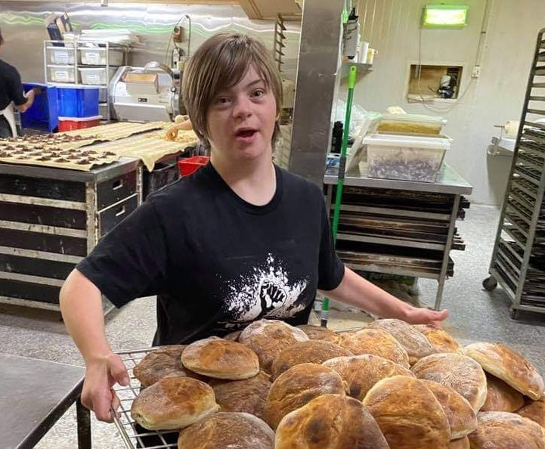**Track School Work experience** – Currently, work experiences for most students with disability is poor or absent. We share [Rhiannon’s work experience](https://www.youtube.com/watch?v=8UH-p7NrnxM) (6.26 minutes), a story about Rhiannon’s successful work experience at her local Bakery. Rhiannon’s mother, Di, thought carefully about the tasks her daughter would be performing and prepared the employer and Rhiannon as much as possible prior to the work experience actually happening. Rhiannon was prepared for success as her mother collaborated with the employer and the employer was receptive to her input.

We strongly recommend this video be adopted as an exemplar of good practice towards providing a system that supports genuine work experience for young people with a disability whilst they are at school, and also changing community attitudes, upskilling the capacity of parents, and lifting employer engagement.

# Conclusion

We appreciate the opportunity to provide this submission and encourage the Audit Office to adopt our recommendations and suggestions. We welcome any further opportunity to discuss the matters raised and the solutions put forward.

1. NSW Ombudsman report: https://www.ombo.nsw.gov.au/ data/assets/pdf_file/0019/138151/NSW-Ombudsman-Inquiry-into-behaviour- management-in-schools.pdf - please note this link is broken – page does not exist.
2. Disability Royal Commission [Research Report - Outcomes associated with inclusive segregated and integrated settings for people with disability;](https://disability.royalcommission.gov.au/system/files/2023-09/Research%20Report%20-%20Outcomes%20associated%20with%20%27inclusive%27%2C%20%27segregated%27%20and%20%27integrated%27%20settings%20for%20people%20with%20disability.pdf) Pg 170
3. Ibid.; p 112
4. Sharples, J., Webster, R., Blatchford, P., Making the best use of teaching assistants Guidance Report (2021) Education Endowment Foundation; p 6.
5. NSW Department of Education website, [Your Career Journey](https://education.nsw.gov.au/about-us/careers-at-education/why-work-at-education/your-career-journey#%3A%7E%3Atext%3DWith%20nearly%20100%2C000%20employees%20working%2Cbeyond%20your%20initial%20job%20description)
6. Budget Estimates 2023-24 Hearing – 24 October Supplementary Questions; p109
7. ASQ - Hon Kate Washington - Families and Communities, Disability Inclusion - received 7 December 2023.pdf; p49
8. [Australian Bureau of Statistics, Disability, Ageing and Carers, Australia: Summary of findings](https://www.abs.gov.au/statistics/health/disability/disability-ageing-and-carers-australia-summary-findings/latest-release) (2018 data table ‘People with disability by state or territory of usual residence’) section, last accessed 17 November 2023
9. <https://research.qut.edu.au/c4ie/2020/10/15/what-does-exclusionary-discipline-do-and-why-should-it-only-ever-be-used-as-a-last-resort/>
10. <https://research.qut.edu.au/c4ie/2020/10/15/what-does-exclusionary-discipline-do-and-why-should-it-only-ever-be-used-as-a-last-resort/>