****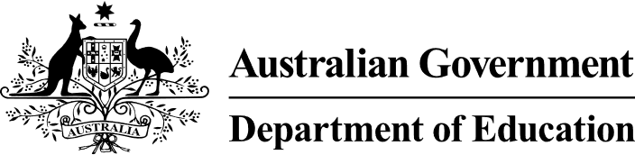



**11 December 2023**

# EMM Statement

**Better and Fairer Education System Review and the next National Education Funding and Reform Agreement**

Ministers received the Expert Panel report into the National School Reform Agreement (NSRA) and thanked the panel for their work.

Having considered this report, Ministers agreed that the next NSRA must deliver on the Alice Springs (Mparntwe) Education Declaration.

The Alice Springs (Mparntwe) Education Declaration set a joint vision for a world class education system that encourages and supports every student to be the very best they can be, no matter where they live or what kind of learning challenges they may face.

Australia’s future social and economic prosperity is reliant on an excellent and equitable education system.

There is much work to do to fulfil this commitment, which Ministers re-affirmed today. This work will be the focus of the next NSRA.

The next NSRA is expected to focus on the following three key outcomes the education system must strive for in order to ensure all young Australians access an education which supports them to reach their full potential.

1. **Equity and Excellence** – schools and education systems are equipped to provide equitable learning opportunities to all students.
2. **Wellbeing for learning and engagement** – students are provided with appropriate support, experiences, teaching and resources to positively and confidently engage in learning.
3. **A strong and sustainable workforce** –teachers and non-teaching school staff are supported to innovate and be at their best to ensure young Australians thrive in their education. A sustainable workforce means that the Australian community recognises the value teachers bring to students, communities and the economy, more Australians consider a career in teaching, and there is a high retention rate.

The next NSRA will identify the reforms requiring a coordinated national effort but recognises each jurisdiction’s unique context, and across all sectors, to progress these key outcomes.

The report is one of a number of inputs to the next agreement.

All Australian Education Ministers are committed to closing the gap in educational outcomes, and delivering an education system that supports young Australians of all backgrounds to achieve their full educational potential.

Full funding for every school is crucial to achieving a more equitable education system. Education Ministers are committed to working together to get every school to a minimum of 100% of the Schooling Resource Standard (SRS).

A detailed summary of the [Summary report](https://www.education.gov.au/review-inform-better-and-fairer-education-system/resources/review-inform-better-and-fairer-education-system-summary-report) can be found on the Department of Education website.